**Emergency and Backup LED control unit with UPS and darkness functionality**

**Know your system on the outside**



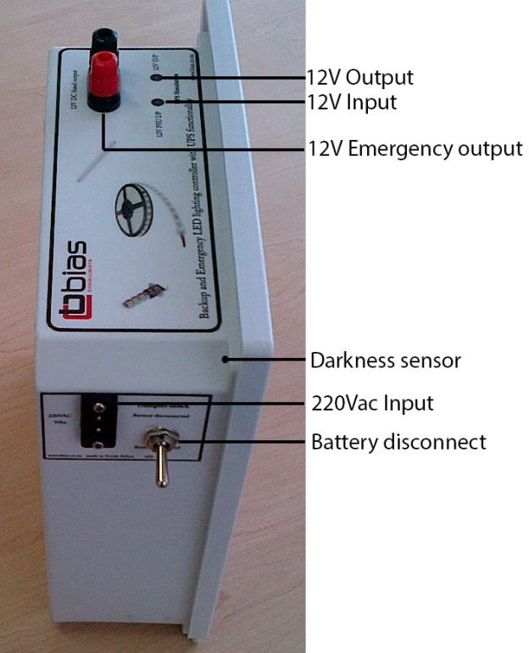

1. **Battery Disconnect switch**

This switch is used to disconnect the internal (7Ah/18Ah/22Ah) or external (120Ah/150Ah) battery from the control. It is the master switch and should only be in the “Disconnected” position when the unit is in transport or in storage. It prevents the battery from draining completely when the unit is not in use for long periods. The switch is rated 10A. When you first receive your unit toggle the switch to the “connected” position.

*NB* the battery will not charge if this switch is in the “disconnect” position.*

1. **220V AC input**

The 220V AC input has two functions. It determines when there is a power failure by monitoring the mains (220VAC) and it is also connected to the internal lead acid battery charger. When you first receive your unit plug the AC 2 pin adapter into a wall socket

1. **Darkness Sensor (if installed)**

The darkness sensor is connected to 2m of twin flex which should be positioned so that it will detect when there is inadequate light and hence tell the unit to switch on the LED’s.

The darkness sensor can be disabled by placing a bypass jumper on JP1 on the PCB.

NB, *Do not mount the darkness sensor close to where the lights will switch on as this will cause the unit to shut down or flicker.

NB** you can extend the cable if required

TIP : The sensitivity can be adjusted inside the unit and is explained under **“Know your system inside”**

Only trial and error will prove best position for this sensor.

1. **12V DC Emergency output or terminal poles**

The black and red terminal poles are where you can connect your LED strips. These are fused 12V outputs.

NB* see **“Know your system inside”** for fuse replacement information.

**NB** NEVER SHORT OUT CIRCUIT THE TERMINAL POLES AS IT WILL BLOW THE FUSE.**

Connect the + wire from the LED’s to red and the – wire to black.

TIP: It is good practise and safe to switch the master switch to “disconnected” while wiring up your LED’s. This will prevent accidental short circuits.

1. **12V DC input for UPS simulation (if installed)**

This input is used when you want to run your LED lights during times when there are no power outages. Connect any 12V 3A-8A DC power supply to the input to provide 12V to your LEDS’s. If there is a power outage the unit will switch over to battery power.

TIP: You don’t have to use the 12V (out) under UPS simulation to connect your LED’s. Simply connect them to the terminal poles.

1. **12V DC Output for UPS simulation (if installed)**

This output is the same as the master terminal poles (Red and black) it is mostly used where one would like to connect a router/modem or other 12V computer related devices.

1. **The +12V and -12V croc clips on the 80Ah to 150Ah unit**

These clips are used to connect to the bigger batteries. Always connect (-) first. Make sure the master switch is in the “disconnect” position.

When using the control box with the bigger batteries make sure you position the box in a well ventilated area, this is so the charger inside breath as it is FAN cooled.

**Know your system on the Inside**

**12V 80-150Ah unit**



**12V 7-24Ah unit**



1. **Darkness Sensor (if installed)**

Some units may not have the darkness sensor as it was not requested to be incorporated. The darkness sensor will only activate the unit if it is dark outside.

The darkness sensor can be disables by placing a bypass jumper on JP1 on the PCB.

1. **UPS input and UPS output**

The UPS input and output is used when you want the unit to turn the LED’s on even when there is power. Simply connect a 12V power supply to the UPS input.

1. **Fuse**

The fuse protects the unit against overloading as well as short circuits. Should the unit not switch the LED’s on please check the fuse. The rating of the fuse is 6-8A 250Vac 20mmx5mm slow blow.

1. **Darkness sensor adjust**

The sensor adjustment can be used to adjust the sensitivity of the darkness sensor. It is a 25 turn potentiometer and one can use a small screwdriver to adjust the sensitivity.

Counter clockwise=more sensitive, clockwise=less sensitive.

Test the sensitivity by closing the darkness sensor with your hand. Remember to leave the mains cable unplugged.

TIP: The darkness sensor can be disabled by placing a jumper on the PCB names JP1 or “BYPASS JUMPER”

1. **Battery cut off adjust**

To protect the battery against total discharge for prolonged power outages it is equipped with a low voltage cut off. The low voltage cut-off is factory adjusted to 11.5V and should not be adjusted unless you have a bench power supply available.

**How do I test the system?**

1. Connect your LED’s to the unit with the master switch on the “Disconnected” position. Make sure you connect + to red and – to black of the terminal poles
2. Connect the 220V AC 2 pin power plug to the wall plug as well as the unit.
3. Toggle the master switch to the “Batt connected position”
4. It is recommended at this stage to leave the system on so that the lead Acid battery can charge. (for testing purposes a few minutes should be fine)
5. Unplug the 2 way mains AC power cable (to simulate a power failure)
6. If there is no darkness sensor or of the sensor has been disabled with a jumper, you will hear a loud click from the relay and the LED’s will turn on in less than 2 seconds.
7. If you reconnect the 220V AC mains cable the LED’s will turn off.
8. If you are using a darkness sensor, unplug the mains cable to simulate a power failure. IF it is still light the unit will not switch on the LED’s. Now close the darkness sensor with a cover or your hand. You should hear the relay and the system will switch on.
9. Once the system is tested, leave it connected to the mains indefinitely. The charger will keep the battery charged.
10. Test the system regularly.

**Troubleshooting**

1. The system does not switch on the LED’s.

* Make sure the switch is in the “Batt connected” position.
* Leave the unit on for 1-2 hours, the battery could be flat
* Insert the “darkness disabled’ jumper and test the system. Should the system work at this point it could be a defective darkness sensor. You may try to adjust the darkness sensitivity to see if it will solve the problem.
* Check the fuse on the PCB.
* Check the connection at the red and black terminal poles
* Check the polarity of the led’s, you may have them connected incorrectly

1. The battery does not charge or does not hold charge

* Open the unit.
* Plug the mains cable in so that you have 220Vac connected to the unit.
* Look at the charger, there will be an indicative LED. It should glow red or green. Red=battery charging, green= battery fully charged.
* If there is no LED the charger is faulty.

**Preventative maintenance**

1. It is good practice t cycle the battery to prolong its economic life. Run the unit at least once every 2-3 weeks until the battery is flat and the charge it up again.
2. The economic life expectancy of a lead acid battery is roughly 1-2 years. Should you find the on time of the system to deteriorate it is time to change the battery.
3. Should you wish to make any changes or add any functionality but are unsure on how to proceed or if it is safe please don’t hesitate to contact the team at BIAS consultants cc.

Remember , make this project fun and keep it green.

We welcome any photos, suggestions and applications on how you use the system

Mail to [info@bias.co.za](mailto:info@bias.co.za) or visit any of our websites.

[www.bias.co.za](http://www.bias.co.za)

[www.smartleddesign.co.za](http://www.smartleddesign.co.za)

[www.touchscreenwarehouse.co.za](http://www.touchscreenwarehouse.co.za)

BIAS JHB 011 708 7007

Unit 33A Kya North Park, Bernie Rd, Kya Sands, Randburg

BIAS KZN 032 947 2783

Unit 4 Laguna Seca Park, Lee Barnes ave, Ballito, Durban

Remember your unit carries a 2 year warranty and the battery 1 year.

Yours sincerely

The BIAS team.